**E-commerce**

**Shoe Flip Mobile**

**Application**

**Submitted by**

Yasir Ali : 397877

Table of Contents

INTRODUCTION 3

Shopping Made Convenient: 3

Key Aspects That Underscore the Importance of the Shoe Flip Application: 3

Visual Development Phase: 4

App Logo Design: 4

Sign In & Sign Up: 5

Sign In Screen: 5

Create Account with Email: 5

Quick Sign Up with Google: 5

Forgot Password & Reset Password: 5

Fingerprint & Face ID Lock Setup Screen: 6

A Portal to Footwear Fashion: 7

Home Overview: 7

Featured Products: 7

Collections Section: 7

Discover All and Categories: 7

Search and Filter: 7

Product Detail: 7

Cart: 7

Checkout and Payment: 9

Card Management: 9

Messaging Area: 9

Menu Option: 10

Profile Option: 10

Settings Option: 10

Challenges: 11

Solutions: 11

Conclusion: 11

References: 11

Design Influences: 12

# INTRODUCTION

The growth of specialised online shopping applications in the dynamic world of e-commerce and digital marketplaces has changed the way consumers interact with retail. In this fast-paced digital age, shopping isn't just about buying things anymore; it's about convenience, variety, and enjoying the experience. This section examines the origins, evolution, and significance of such applications, with a focus on the online shoe selling industry and the "Shoe Flip Application."

Remember the days when buying a new pair of shoes meant traveling to multiple stores, trying on countless options, and often not finding the right fit or style? Those days are gone! With the advent of e-commerce, and now, specialized applications like Shoe Flip, shoe shopping has become a breeze. Our application is born out of a simple yet powerful idea: to make shoe shopping fun, easy, and accessible for everyone. It's a response to the growing demand for a more efficient, hassle-free shopping experience that caters to the diverse needs and preferences of consumers worldwide.

The significance of applications like Shoe Flip lies in their ability to offer unmatched convenience, variety, and personalized shopping experiences. Unlike traditional retail stores, these apps allow consumers to explore, compare, and purchase footwear from a vast array of options, all from the comfort of their homes. Whether you're a professional athlete looking for high-performance sports shoes, a fashionista seeking the latest trends in footwear, or someone in search of comfortable daily wear, our app has something for everyone. This not only breaks down geographical limitations but also introduces a level of ease and accessibility that transforms the entire shopping experience.

That the perfect shoe is not just about looks; it's about fit, comfort, and style. That's why our app comes equipped with features like detailed descriptions, high-resolution images, and customer reviews. Advanced filters allow you to sort by size, color, brand, and even the type of activity or occasion, making your search as specific as you need.

# Shopping Made Convenient:

One of the biggest advantages of the Shoe Flip Application is the convenience it offers. Shop anywhere, anytime, without worrying about store timings or queues. With secure payment options, fast shipping, and a straightforward return policy, your shopping experience is hassle-free and satisfying.

# Key Aspects That Underscore the Importance of the Shoe Flip Application:

1. The Shoe Flip Application brings the entire shoe store to your fingertips. Users can browse, select, and purchase their favorite shoes anytime, anywhere. This removes the limitations of traditional store hours, offering the freedom to shop at your convenience, whether it's late at night or early in the morning.
2. The app simplifies the entire shoe shopping process. From a wide range of filters for easy search to one-click purchases, the Shoe Flip Application streamlines the way people shop for shoes. Users can effortlessly compare different products, read reviews, view high-quality images, and manage their orders, all within a single platform, saving both time and effort.
3. The Shoe Flip Application integrates state-of-the-art security features. It employs advanced biometric authentication methods like Face ID detection and fingerprint scanning, ensuring that only authorized users can access their accounts and validate purchases.
4. Consistent with the dynamic nature of e-commerce, the Shoe Flip Application continuously evolves. Regular updates bring new features and improvements, catering to the changing preferences and needs of users.

# Visual Development Phase:

In the creation of the Shoe Flip Application, several key tools played important roles in bringing the design concept to real:

1. Figma: Figma was the cornerstone in the app's design process. Through Figma, we developed detailed wireframes, visual mockups, and interactive prototypes, ensuring a seamless and user-friendly design
2. Canva: Canva was utilized for creating various graphic elements and promotional materials for the app. Its user-friendly interface and vast library of templates and design elements made it an ideal choice for quickly producing high-quality visuals
3. Unsplash: For high-quality, free images, we turned to Unsplash. This platform provided us with a diverse range of photographs to use within the app, particularly for showcasing shoe styles, fashion trends, and lifestyle imagery.
4. Pixels for Images: Similarly, Pixels was another source for stunning and free images.. Whether for background themes, banner images, or product showcases, Pixels offered a rich array of options to enhance the UI of the Shoe Flip Application.

# App Logo Design:

The logo is for "FlipFootwear" a sleek and modern design. the logo, encased within a circular background in a calming shade of blue, displays trust and reliability. The brand name, "FLIPFOOTWEAR," is clearly visible beneath the shoe graphic, ensuring instant brand recognition.

Figure 1 FlipFootWear Logo displays trust and reliability

# Sign In & Sign Up:

## **Sign In Screen:**

The sign-in screen greets users with a sleek design that reflects our shoe brand's stylish values, displaying the Shoe Flip Application logo against our signature colour scheme. The form is straightforward, making it simple for users to enter their information and get started.

## **Create Account with Email:**

The account creation is a breeze, guiding new users through a step-by-step process to set up their profile. It asks for essential details such as email, a secure password, and includes a verification step to confirm authenticity.

## **Quick Sign Up with Google:**

This option streamlines the registration process by allowing new users to sign up using their existing Google accounts. It's a fast-track into the world of any online application, and enabling immediate access to our shoe collection.

Figure 2 Create account page

# 

Figure 3 Sign Page

Figure 1 Shoe Flip Footwear Front Page

# Forgot Password & Reset Password:

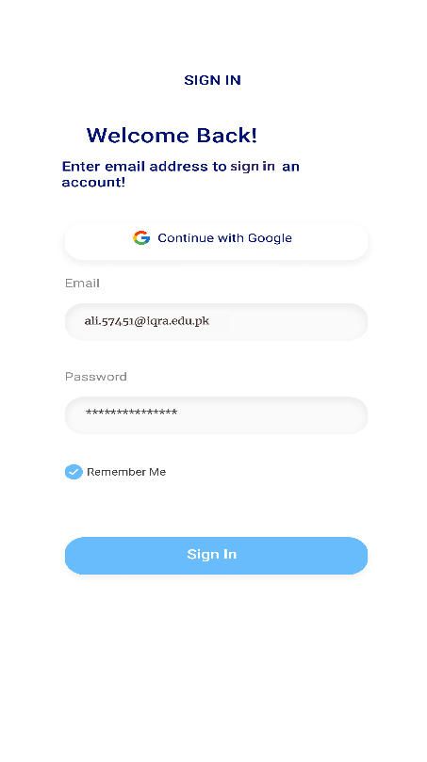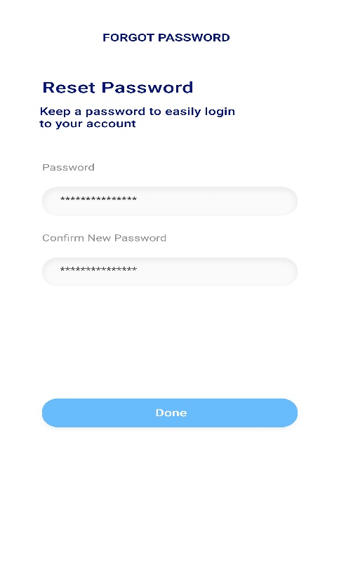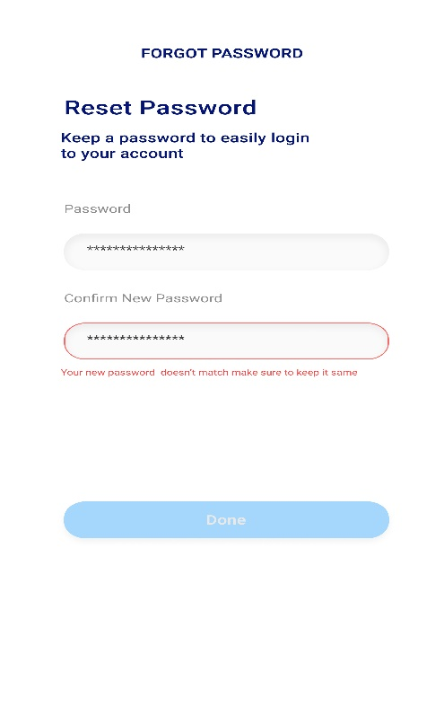The "Forgot Password" and "Reset Password" screens for the Shoe Flip Application provide a straightforward and secure process for users to regain access to their accounts. Once the user has identified themselves, they are directed to the reset password screen. Here, users can enter their new password and confirm it to ensure accuracy. The text fields are clearly marked, and the interface provides immediate feedback if the passwords do not match, indicated by the red outline around the confirm password field.

Figure 2 Forgot Password check page

Figure 3 Forgot password login

Figure 4 Forgot Password page

# Fingerprint & Face ID Lock Setup Screen:

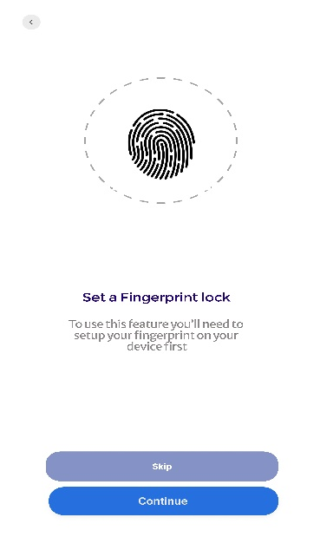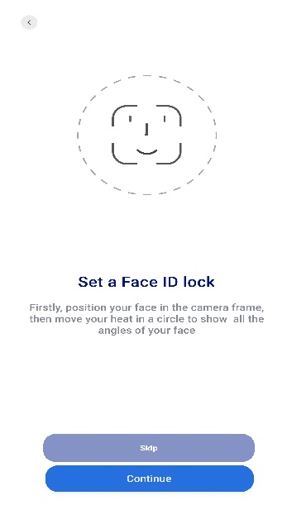The Shoe Flip Application also offers straightforward options for adding extra security with biometric and face ID lock setup features. On the Fingerprint Lock Setup Screen, users can quickly enable a fingerprint lock by following simple on-screen instructions, with a bold fingerprint icon indicating where to touch.

Figure 5 Face I'd lock Page

For smoother experience, the Face ID Lock Setup Screen guides users to secure their app using facial recognition, highlighted by a friendly face outline and easy-to-follow directions for a full facial scan. Both screens come with a 'Skip' button for those who prefer not to use these features, and a 'Continue' button for users ready to enhance their app's security, providing a personalized approach to safeguarding their shopping experience.

Figure 6 Fingerprint lock Page

**A Portal to Footwear Fashion:**

## **Home Overview:**

The home screen is the core of the Shoe FlipFootwear mobile application, offering a full view of the latest footwear trends and quick access to essential functions. With a sleek design, it invites users to browse and discover new arrivals, popular models, and exclusive deals.

## **Featured Products:**

The app featured shoes with their prices, providing a quick glimpse into the latest styles that users might be interested in. Each featured product is displayed with high-quality images and price tags in an elegant format, making it easy for users to decide at a glance.

## **Collections Section:**

#### To help users navigate through different styles, the Collections section categorizes shoes by type, occasion, or trend. Each collection is visually appealing, with tiles representing different shoe styles, complete with names and prices for easy identification.

## **Discover All and Categories:**

#### Users can tap into the 'Discover All' section to view the extensive range of shoes available, with filters to narrow down choices by color, size, or brand. The 'Categories' tab allows users to switch between different segments like Men’s, Women’s, and Children’s footwear, streamlining the search for the perfect pair.

## **Search and Filter:**

The search function is smart and predictive, offering suggestions based on past searches or popular items. Users can select their search with advanced filters, including price range sliders, color spectrums, and size selectors, ensuring they find exactly what they’re looking for.

## **Product Detail:**

The detail screen offers in-depth information about each shoe, including materials, structure, and available sizes. With a clear call action button, users can quickly add their chosen items to the cart or wish list, or proceed to checkout.

## **Cart:**

The 'Cart' screen provides a summary of selected items, mirroring a user's financial overview. Users can view item details, adjust quantities, or remove products as needed. With a clear total amount displayed and an easy-to-find 'Checkout' button, the transaction process is designed to be quick and user-friendly, encouraging a satisfying shopping experience.

This Shoe FlipFootwear app has been thoughtfully designed to combine the advantages of online shopping with the shopping experience at the store, all from a smartphone or tablet. It's a dedicated space for shoe fans to indulge in their footwear passion.

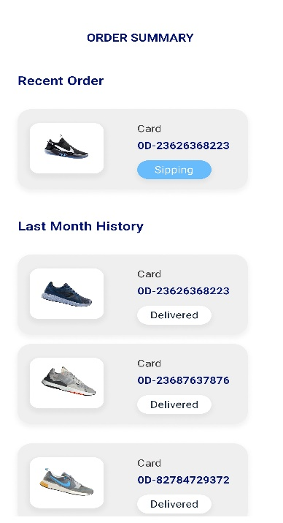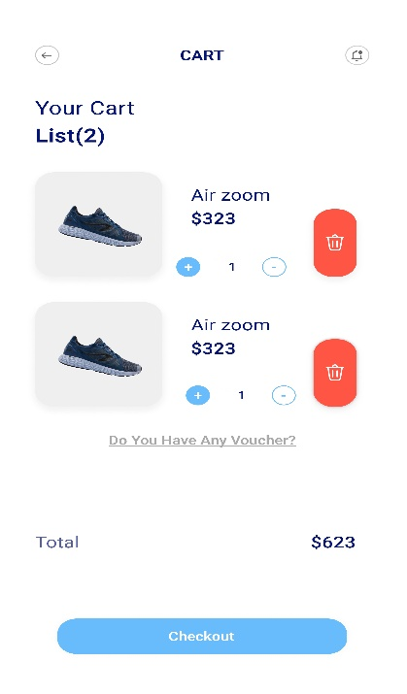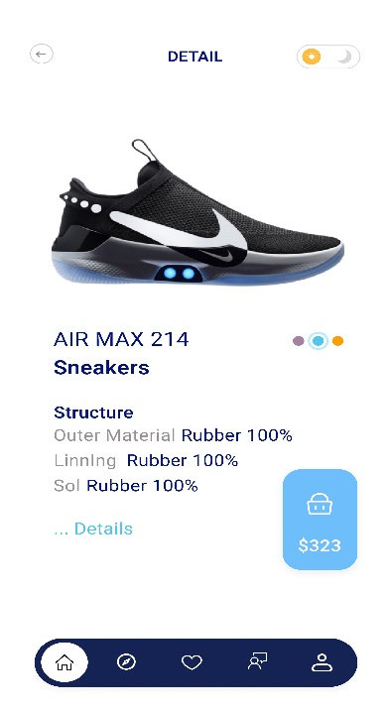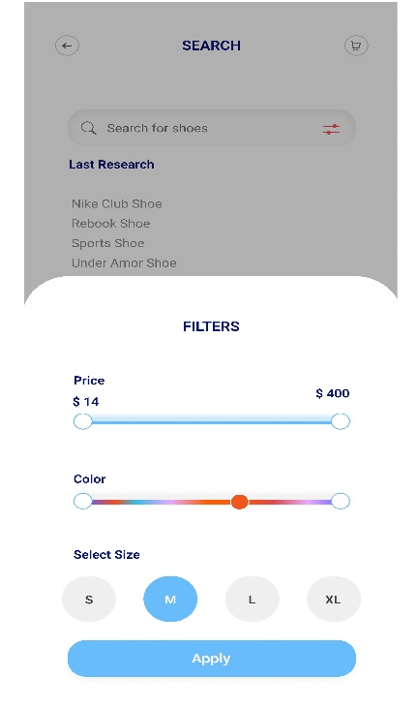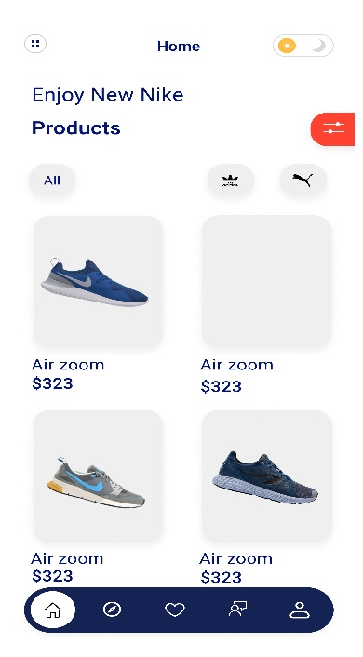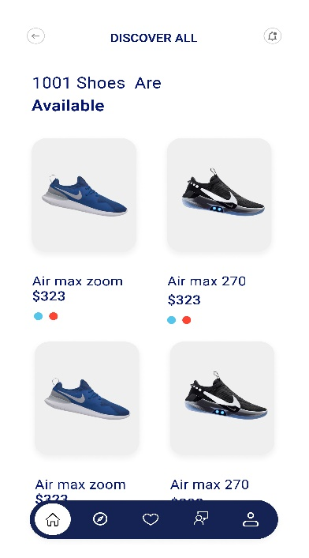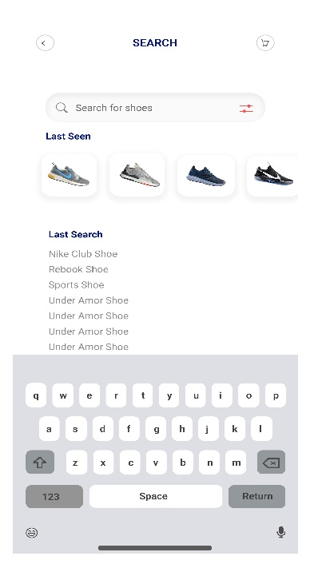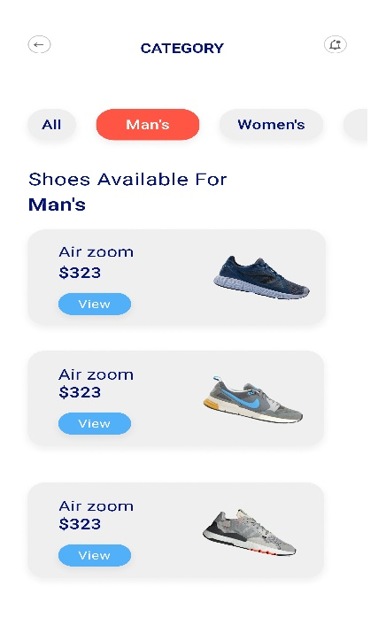

Figure 7 Discover in Total Quantity

Figure 8 Home page of FlipFootwear

Figure 9 Order Summary

Figure 10 Shoe Cart List

Figure 11 Shoe Details

Figure 12 Filter By Color & Price

Figure 13 Shoes Search engine

Figure 14 Category of Shoes

# Checkout and Payment:

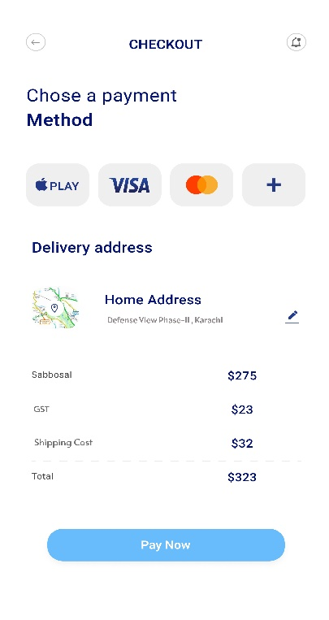When it's time to secure the latest footwear, the checkout screen in the Shoe FlipFootwear app provides a straightforward path to completing the purchase. Customers have choice of payment methods, including popular options like Visa and MasterCard, each displayed with its recognizable logo for easy identification. The addition of a '+' icon suggests that users can effortlessly add new payment methods, enhancing the app's flexibility.

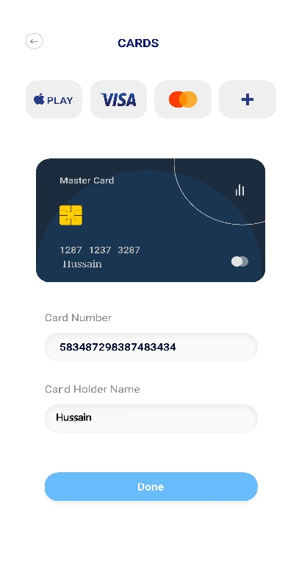The checkout process is further simplified by a clearly defined delivery address section, where users can either confirm their default shipping details or add a new address.

Figure 15 Payment Card Details

# Card Management:

The 'Cards' section of the app displays a visually appealing representation of the user's saved payment cards. Each card is shown with design elements that reflect the actual card brand, such as the color scheme and logo, providing a familiar visual cue to the users. The cardholder's name and the last four digits of the card number are prominently displayed for easy identification. For additional cards, users can input new information in designated fields, where the entered text for the card number and holder's name is neatly displayed.

Figure 16 Payment’s method selection to Pay

# Messaging Area:

1. This is where the user can interact with contacts such as customer support or sales representatives. The design is clean with a user-friendly chat interface.
2. Users can navigate their message history with ease, having the ability to delete conversations to maintain privacy and organization. The 'All Messages' tab keeps the user's inbox manageable, separating 'Read' and 'Unread' messages to ensure they don't miss any important communication.
3. With profile pictures displayed alongside the chat, users can easily identify who they're communicating with. The application also provides settings for the messages, such as notifications, ensuring users are alerted to new messages according to their preferences.

Figure 17 Messages reply details with client

Figure 18 Messaging Area

1. Overall, the messaging area of the Shoe FlipFootwear app is designed to offer users a seamless and organized way to communicate, enhancing their overall experience with the application.

The Shoe FlipFootwear mobile application offers a streamlined navigation experience through its Menu, Profile, and Settings options, ensuring that users can easily customize their experience and manage their account.

# Menu Option:

The menu is a one-stop navigation hub that allows users to seamlessly move between different parts of the app. It includes options like 'All Categories' for browsing the shoe collection, 'Track Order' to check the delivery status, 'Discover All' for exploring the full range of products, 'Location' to set or change delivery addresses, 'Payment Card' for managing payment methods, 'Orders' to review past purchases, and a 'Scan' feature possibly used for a quick search or to scan a product in-store. An accessible 'Setting' option is also available for additional configurations, and there's a 'Sign Out' feature for security and privacy.

# Profile Option:

The profile section gives a personal touch to the app, where users can view and edit their personal information such as name and email address. It’s designed to make sure the user feels at home and can ensure all their details are up-to-date for a more personalized shopping experience.

# Settings Option:

In the settings, users have the power to adjust their app experience to their liking. It includes 'General Settings' for basic app configurations, 'Account Settings' for personal details, 'Change Password' for security, 'Notification' settings to control alerts and updates, 'About Us' for company information, 'Privacy & Policy' to understand data handling practices, and an option to 'Delete Account' should they choose to leave the service. This ensures that users maintain full control over their interaction with the app and their personal information.

Together, these features make up a user-centric interface that prioritizes convenience and customization, reflecting the Shoe FlipFootwear's commitment to a responsive and engaging user experience. Whether it's adjusting app settings, managing personal details, or navigating through the shopping process, the app's design ensures every step is understandable and accessible.

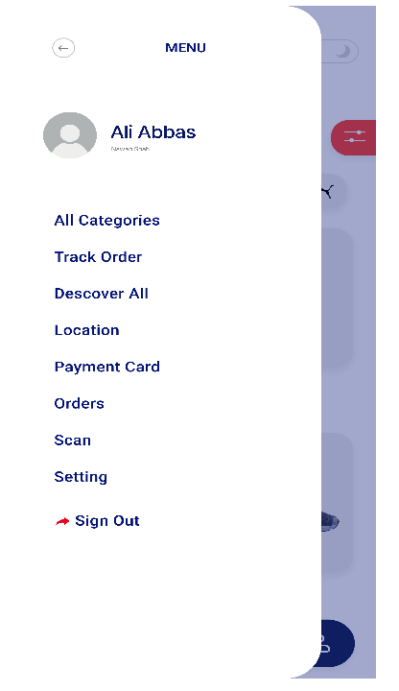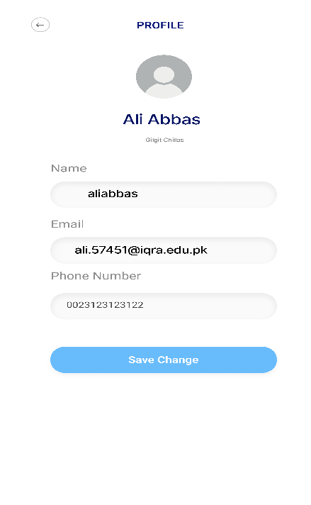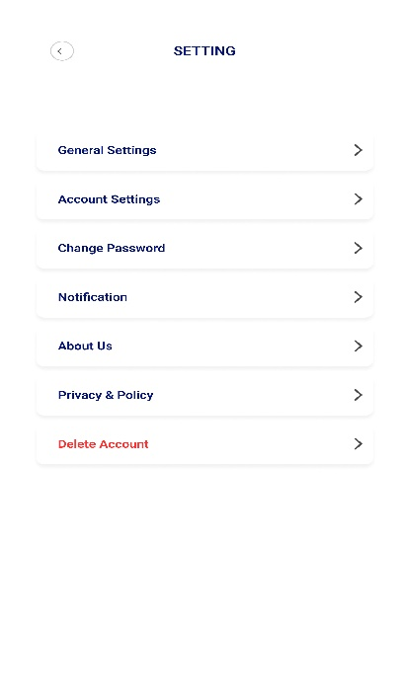

Figure 19 All Setting Fields

Figure 20 User Profile View

Figure 21 Menu Page

# Challenges:

The Shoe FlipFootwear application overcomes key challenges to offer a seamless and engaging user experience. By embracing responsive design principles and a robust design system, it ensures consistency across various platforms and devices. Additionally, accessibility is a corner stone of the app's design philosophy, ensuring that all users, including those with disabilities, can navigate and enjoy the app to its fullest potential.

On the technical side, data security and regulatory compliance are paramount. The app secures user data with state-of-the-art encryption, safe API connections, and regular security audits to uphold the highest standards of privacy and security.

# Solutions:

In addressing the design and technical challenges, the Shoe FlipFootwear application employs specific solutions that enhance user satisfaction and security. Design consistency is achieved through a responsive framework and a centralized design system, ensuring the app looks and functions across all devices. Accessibility is embedded in the app's DNA, with features like text-to-speech and high-contrast mode enabling users of all abilities to engage with the app fully.

From a technical standpoint, the app fortifies user data with advanced encryption techniques, secure server connections, and compliance with international data protection regulations. Regular security checks and updates ensure that the app stays ahead of potential threats, in users that their personal information remains protected. These solutions work in concert to provide a safe, accessible, and consistent shopping experience, setting the Shoe FlipFootwear application apart as a leader in digital retail innovation for footwear.

# Conclusion:

The development of the Shoe FlipFootwear application represents a significant step forward in the combination of fashion and technology. Using advanced design tools and a user-centered approach, we created not just an app design, but an entire digital footwear system. This platform distinguishes itself through its elegant design, simple navigation, and ongoing dedication to diversity, ensuring an enjoyable experience for all users.

The group has navigated difficult design challenges and complex technical demands throughout the design development journey. The application's interface, with its thoughtful colour scheme and engaging layout, demonstrates a thorough understanding of the subject.

The Shoe FlipFootwear app is more than just a marketplace; it's a place where shoe fans can discover, interact, and buy with confidence, knowing they're supported by a platform that respects their passion and their privacy. Looking ahead, we are excited to continue improving and expanding our offerings, responding to feedback, and pushing the boundaries of what a dedicated footwear app can be.

**References:**

1. Figma. (2024, January 10-11). <https://www.figma.com/>.
2. Canva. (2024, January 10-11). <https://www.canva.com/>.
3. Unsplash. (2024, January 11-12). <https://unsplash.com/>.
4. Pixels. (2024, January 11-12-13). <https://www.pexels.com/>.
5. ChatGPT. (2024, January 11-12-13-14). <https://www.openai.com/chatgpt>.
6. Google. (2024, January 10-12-1314). <https://www.google.com/>.

# Design Influences:

Design Influences for Shoe FlipFootwear Application:

1. Alibaba - A global marketplace renowned for its extensive product range and user-friendly interface.
2. Amazon Seller - Known for its efficient seller interface and customer-centric shopping experience.
3. Daraz Online Shopping - Popular for its localized approach and diverse product offerings.
4. Shopify - A leader in providing customizable and intuitive e-commerce platforms.
5. OLX Pakistan - Recognized for its simple, user-friendly design and effective marketplace model.
6. Noon Shopping - Distinguished for its streamlined shopping process and focus on user experience.

Each of these platforms has contributed unique elements to the overall design and functionality of the Shoe FlipFootwear application. Alibaba's vast inventory and layout, Amazon Seller's efficiency in user-seller interaction, Daraz's regional customization, Shopify's emphasis on personalized e-commerce experiences, OLX Pakistan's straightforward user interface, and Noon's streamlined shopping process collectively influenced the development of an application that is not only visually appealing but also highly user-centric and efficient. These inspirations have been instrumental in shaping an app that resonates with modern consumer preferences and stands out in the competitive digital marketplace.